**COMPUTING  
IN  
CARDIOLOGY**

**September 11-14, 2016**

**Vancouver, Canada**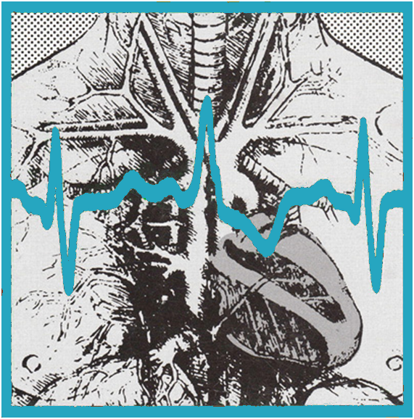

# Sponsors

We would like to thank our sponsors and those who have made generous donations:

|  |  |
| --- | --- |
|  |  |
|  |  |
|  |  |
|  |  |
|  |  |
| logo ESC Working Group - e-Cardiology2_1.jpg | |



# About Next Year’s Conference, CinC 2017

The 2017 Computing in Cardiology Conference will be held in the beautiful city of

# BOARD OF DIRECTORS

President  
Pablo Laguna, PhD  
University of Zaragosa  
Zaragosa, Spain  
  
Secretary   
Leif Sörnmo, DSc  
Lund University  
Lund, Sweden

Treasurer  
Victor Mor-Avi, PhD, FASE  
University of Chicago  
Chicago, IL, USA

Cristiana Corsi, PhD  
University of Bologna  
Bologna, Italy

Olaf Doessel, PhD  
Karlsruhe Institute of Technology KIT)  
Karlsruhe, Germany

Dewar Finlay, PhD  
University of Ulster  
Belfast, UK

Paul Kligfield, MD, FACC  
Weill Cornell Medical School  
New York, NY, USA

Rob MacLeod, PhD  
SCI Institute, University of Utah  
Salt Lake City, Utah, USA

Ex-Officio

Chair of the ESC Working Group on e-Cardiology:  
Goran Krstacic, MD, PhD, FESC  
Director of the Institute for Cardiovascular Prevention and Rehabilitation  
Zagreb, Croatia

Past President   
Peter Macfarlane, DSc  
University of Glasgow, UK

Non-Elected:

Editor, Proceedings   
Alan Murray, PhD   
Freeman Hospital  
 Newcastle upon Tyne, UK

Directors, CinC Physionet Challenge  
Gari Clifford, PhD   
Emory University  
Atlanta, GA USA  
and   
Ikaro Silva  
MIT University  
Boston, MA  
  
Director of Information Services:  
Sheryl Prucka, MSEE  
Prucka Engineering, Inc  
Park City, UT, USA

LOCAL COMMITTEE

Andrew Blaber, Chair  
Kouhyar Tavakolian, Co-chair  
Eric Accili

Guy Dumont  
Matthias Gorges

Simon Rabkin

William New

Volunteers:

Kian Davoudi

Amanmeet Garg

Elaine Baluyut

Maryam Dehghan

Parastoo Dehkordi

Fariba Ghodousi

Al-Haqq Govani

Nazanin Hamzeh

Farzad Khosrow-khavar

Mahan Rahimi

Rashika Raizada

Alireza Akhbardeh

Reza Fazel-Rezai

Michele Touchette

Malcom F Tremblay

Ajay K Verma

Da Xu

Mahdi Yousefi

# Letter from the President

Dear Participant,

Welcome to the 43rd Computing in Cardiology conference. This is the first time that we are meeting in Canada. The Board of Directors of Computing in Cardiology is particularly happy that Drs. Andrew Blaber and Kouhyar Tavakolian have volunteered to host the conference in Vancouver in Western Canada, and have prepared an excellent meeting and social program. The organizers are part of a long tradition where engineering is successfully applied to physiology. A very large number of abstracts have been submitted, by far exceeding the number of submissions of previous conferences held on this continent. So it can be concluded that the conference remains in good health and attracts numerous contributions in the field.

We encourage any of you who would like to consider hosting a Computing in Cardiology meeting to step forward. Advance planning is welcome, so please feel free to contact any member of the Board of Directors now if you think you would like to host a meeting in the future. If the conference has not yet been held in your country, this suggestion has particular relevance for you.

In an attempt to keep the conference at the frontier of research, we have introduced several new initiatives. For the first time, we have included in the program three special sessions organized by experts in the field: **1) ECG Imaging in Atrial Electrophysiology, 2) Recent Advances in Seismocardiography and Ballistocardiography, 3) QT, Drugs and Computing.**

To further stimulate the clinical value of the research work of the CinC community, we have set up the **Clinical Needs Translational Award** (CTA) in collaboration with, and the support of, the e-Working Group of the European Society of Cardiology (ESC). Following the success of last year's clinical talks delivered in Nice, this year will continue with two talks aiming at better connecting clinical and engineering aspects. The titles are *Implantable Device Detected Atrial Tachyarrhythmias: A Few Clinical and Technical Considerations*, which will be delivered by Steven Swiryn and *Cardiac Imaging and Modeling: Predicting the future* to be presented by Ravi Ranjan.

The *Mortara Fellowships* represent an extraordinary means for “reducing the distance” for young researchers with limited means so that they can present their work at CinC. T*he Rosanna Degani YIA Competition* aims at promoting high standards in research quality by highlighting best research projects conducted by young investigators. The *PhysioNet-CinC Challenge* represents a major effort to direct research to clinically relevant topics, where annotated data is provided to the research community. These now established features of CinC, together with the new initiatives, will benefit from feedback from all of you as a scientific community. I encourage you to provide input to the Board of Directors on these issues, as well as any other issue, as a reaffirmation of our commitment to do our best for guiding the steps of our organization in coming years.

I can advise that some members of the Board will end their term next year, and will need to be replaced. Those of you who would like to serve on the Board, and thus to contribute to the CinC community, are invited to submit your candidacy. Details of how to do so will be announced later in the year.

I hope you will have a scientifically stimulating meeting that will give you new ideas for your future research and inspire you to submit your work for presentation at next year's meeting, which will take place in Rennes, France, from 24th -27th, September, 2017. May I also take this opportunity to thank Drs. Andrew Blaber, Kouhyar Tavakolian and all of the Local Organizing Committee for the work they have done in the preparation of Computing in Cardiology 2016. I am sure it will be a great success.

Best wishes,

Pablo Laguna

President, Computing in Cardiology

# Welcome to Vancouver

Dear Colleagues,

On behalf of the organizing committee it is our pleasure to welcome you to Vancouver, Canada’s gateway to the Pacific. We are honored to host the 43rd annual meeting of Computing in Cardiology, for the first time in Canada. We have endeavored to provide a venue to allow for the high level of social and scientific interaction you have come to expect at these meetings.

The host institution for this meeting is Simon Fraser University; however, faculty members and students from the University of British Columbia are also playing an important role and we would like to acknowledge their participation and effort. This interaction between Vancouver’s major health, computing science and engineering institutions is a testament to the philosophy of Computing in Cardiology; to foster collaboration and innovation between engineers and computer scientists with physiologists and clinicians.

For this meeting we have prepared a symposium highlighting the challenges faced by the human space exploration. Held at SFU’s Harbour Centre campus, the topic of this year's symposium is **Cardiology in Space.** We have assembled six renowned experts in the field who present their research perspectives on the heart and cardiovascular system in the space environment. The symposium will be opened by Dr. Robert Thirsk (astronaut, mechanical engineer, medical doctor, Chancellor of the University of Calgary). Dr. Thirsk was Canada’s first long-term inhabitant of the International Space Station.

Vancouver is consistently ranked one of the top 10 most livable cities in the world and the best place to live in North America. The conference venues at SFU Harbour Centre and the Marriott are located within minutes of the waterfront and boast views overlooking picturesque Burrard inlet and the North Shore Mountains. For many years the region has been a cultural meeting place and we encourage you to take the time to explore this global fusion of cultural and culinary delights.

Our conference staff is prepared to help in any way possible to make your stay an exciting and rewarding one.

Welcome.

ANDREW BLABER KOUHYAR TAVAKOLIAN

Chair of the LOC Co-Chair of the LOC

**Maps of Vancouver Downtown**

|  |
| --- |
|  |
|  |

Floor Map for Vancouver Marriott Pinnacle

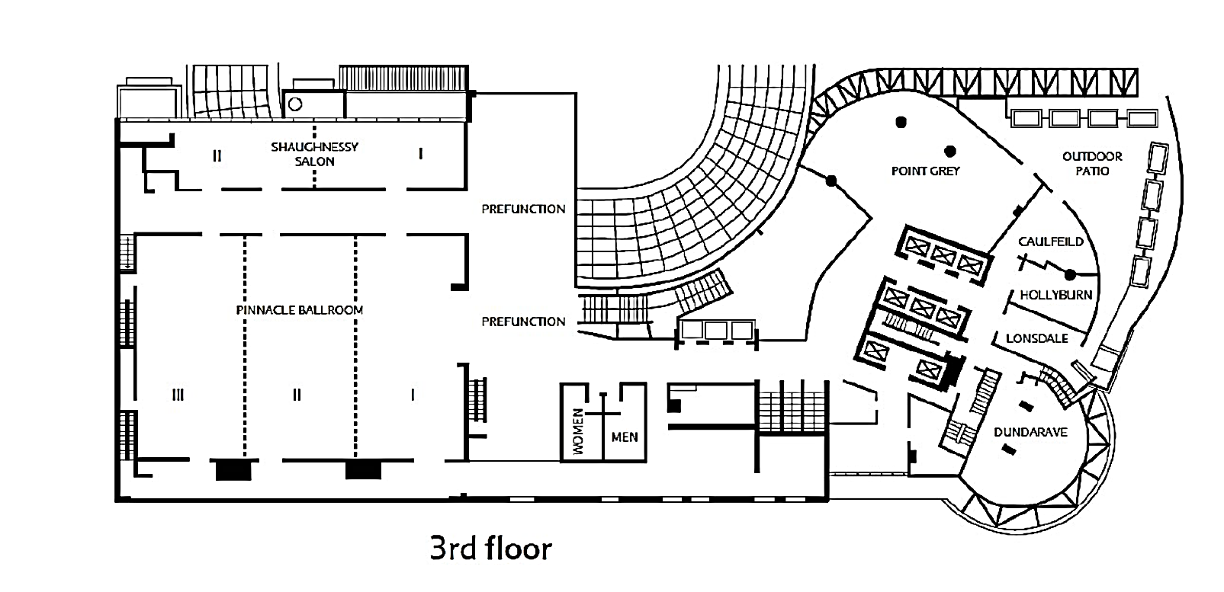

# Meeting Site

The 43rd annual international conference of Computing in Cardiology will meet at the Marriot Pinnacle Hotel, Vancouver Canada, from Sunday, September 11th through Wednesday, September 14th, 2016 (Map A).

Computing in Cardiology 2016 will begin at 13:00 of Sunday Sept 11th at Simon Fraser University, Harbour Centre, with a special symposium of invited speakers (Map B).

Scientific sessions, on Monday, Tuesday and Wednesday will take place at Marriot Pinnacle Hotel in Vancouver Down town. The place is easily reachable by Skytrain (Station stop “Waterfront Station”**,** Map A). The conference is being held in lecture rooms as outlined:

* Opening and closing ceremonies Pinnacle II and III
* Regular oral sessions 3rd floor (see schedule)
* Poster sessions Pinnacle I

Please refer to the floor maps for room localizations. The buildings and lecture rooms will be clearly marked with the Computing in Cardiology signs.

## Transportation

The transportation system is very efficient and you will be able to come directly from the airport to the conference place via the rapid rail system (Skytrain) on the Canada Line. For this you will need to walk to Canada Line station in the airport and get off at the Terminal station “Waterfront”, which will take you 30 minutes. The station is only few minutes of walk away from the conference sites (Map B).

For your transportation in Vancouver and around, the website http://www.translink.ca/ will help you select the best journey (bus/Seabus /Skytrain).

# Hotel & Practical Information

## Accommodations

CinC2016 has negotiated a discounted group rate for the conference hotel: Vancouver Marriott Pinnacle Downtown. This will give you quick access to the conference and activities. For information on how to register please click [here](https://resweb.passkey.com/Resweb.do?mode=welcome_ei_new&eventID=13782407). If you are unable to stay at the Marriott we refer to our website by [Tourism Vancouver.](http://www.tourismvancouver.com/cinc2016/) We recommend a hotel/hostel close to the conference place in downtown Vancouver.

## Climate

 Warmed by Pacific Ocean currents and protected by a range of mountains, Vancouver's weather is mild year-round. From high 70's Fahrenheit (low 20's Celsius) in summer to a mild mid 40's Fahrenheit (0º to 5º Celsius) in winter, the climate is always hospitable. Our winters are wet, but it rarely snows, except on our local ski hills. During the conference period, early September, we expect a pleasant weather.

## Money/currency

We recommend all visitors use Canadian currency (the Canadian Dollar - CAD) when travelling within Canada. Visitors can exchange currency at Canadian chartered banks, trust companies, credit unions, or at offices of foreign exchange brokers, but it is advised to have local currency on hand prior to arriving. Some hotels, merchants, restaurants and suppliers accept US or other foreign currency at a pre-determined rate, which may differ from the daily rate posted by financial institutions.  The Canadian Dollar is made up of 100 Canadian cents. Coins are in denominations of 5 cents (nickel), 10 cents (dime), 25 cents (quarter), $1 (loonie), and $2 (toonie).  Notes are in denominations $5, $10, $20, $50, $100 and $1,000.

## Help-line and Emergency phone numbers

If you have got questions during the conference we have assigned a local number to call (+1-604-782-4269) and the same number will be available if you download WhatsApp application on your smart phone. On the conference site we would suggest you to approach the helps desk.

For emergencies you would call 911.

## Calling to and from Canada

Electric standards

110 Volts / 60 Hertz

## Tips for a pleasant trouble-free stay

* You are strongly recommended to respect smoking/no smoking signs in public places.
* It is pretty common to leave something after a bite to eat or a drink. Extra generosity will never hurt.
* If you are driving, park only where authorized and respect speed limits on highways and motorways.

Useful link

http://www.tourismvancouver.com/cinc2016/

## Things to Do in and Near Vancouver

### Things to do in Vancouver

Culture and visits, shopping, gastronomy, night life, surroundings, sport activities

All details can be found on http://www.tourismvancouver.com/activities/

### The conference registration and information desk will be located at the SFU Harbour Centre on Sunday and at Marriot Pinnacle Hotel for the rest of the conference during the following hours:

* Sunday, 6th September 13:00 – 18:00
* Monday, 7th September 08:00 – 13:00
* Tuesday, 8th September 08:00 – 18:00
* Wednesday, 9th September 08:00 – 18:00

## Internet Access

Within the conference rooms, wireless network will be available free of charge. The network name and password will be given at the registration desk. For those using **eduroam**, this network is available at the Sunday Symposium site. The only device you need is a WiFi-enabled laptop or smartphone. Should you need assistance in getting connected, please ask the nearest volunteer for help.

# Social Program

**Meals**

The delegates will not have to worry about most of the meals. Just, in order to keep up the meeting timetable, the attendees are kindly asked to proceed quickly to the restaurants or buffet immediately after the session finishes.

**Accompanying Persons (Guests)**

The accompanying person (guest) registration allows the guest to attend the reception on Sunday evening, the Monday social event starting at 13:00 with lunch, participation as an activist or passivist, and the gala dinner, to be held at the Science World at the Telus World of Science. Doors will open at 18:45 and dinner will start at 19:30. Dancing and entertainment will start at 21:30.

**Monday**

Each year at CinC, Monday afternoon is set aside to facilitate a social event. This is an important part of the conference program as it allows attendees to network and relax in a more informal setting away from the scientific sessions. It is also the opportunity to uncover Vancouver. Please consider the following remarks: All social program participants are required to wear their CinC badges. As the social program starts immediately after the sessions, the participants may consider comfortable informal dress for the whole-day. However the dressing code for the gala dinner should not be streetwear style! The social program will start at 13:00 on Monday with lunch at the Conference Venue. As it is traditional in the Computing in Cardiology Social Program, participants can choose between Activist or Passivist activities on the registration website.

The last event on Monday is the Gala Dinner. The Gala dinner will happen at Telus World of Science, on the south eastern part of downtown, accessible by Skytrain station as in map C and D.

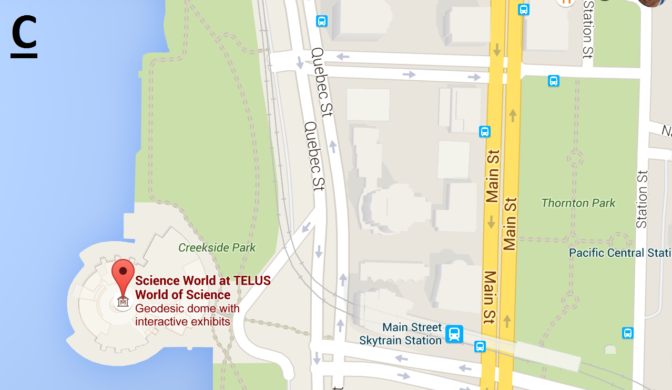

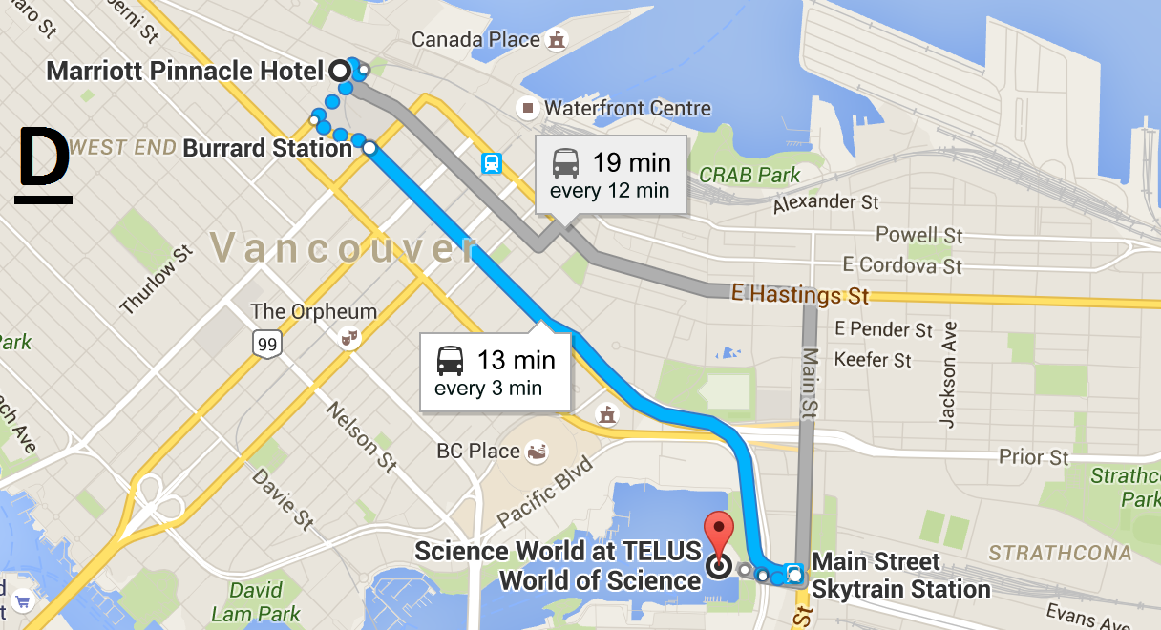

## Monday Social Program

**Passivist**

Your tour of Vancouver will start with a cruise aboard the Pride of Vancouver. The sightseeing boat will depart from Bayshore West Marina in Coal Harbour and cruise to the culturally historic [Granville Island](http://granvilleisland.com/) where you will have one hour to visit the artisan shops and the world famous market. To help plan your time on the island click [here](http://granvilleisland.com/discover-island/visitors-guide). After your exploration of the Island the boat will then cruise out of False Creek, past English Bay and over to West Vancouver; it here where some of the most beautiful views of the Pacific sunsets and Vancouver Island are found. Not surprisingly, this is also where some of the most expensive properties in Canada are. The boat will then proceed on a leisurely course back under the Lions Gate Bridge, past Stanley Park, around the inner harbor, and back to the marina.

|  |  |
| --- | --- |
|  |  |

**Activist**

The activist group will be given a bicycle. You can find a map of cycling routes around Vancouver here: http://vancouver.ca/files/cov/map-cycling-vancouver.pdf

There are two options for activist group.

Option 1: We will be taking the scenic [seaside bike route](http://www.letsgobiking.net/2010/05/10-seaside-four-routes.html) (Voted #1 in the area) around [Stanley Park](http://vancouver.ca/parks-recreation-culture/stanley-park.aspx) and all the way to culturally historic [Granville Island](http://granvilleisland.com/) where you can enjoy one of the oldest parts of the town. You will be able to visit the artisan shops and the world famous market. To help plan your time on the island click [here](http://granvilleisland.com/discover-island/visitors-guide).

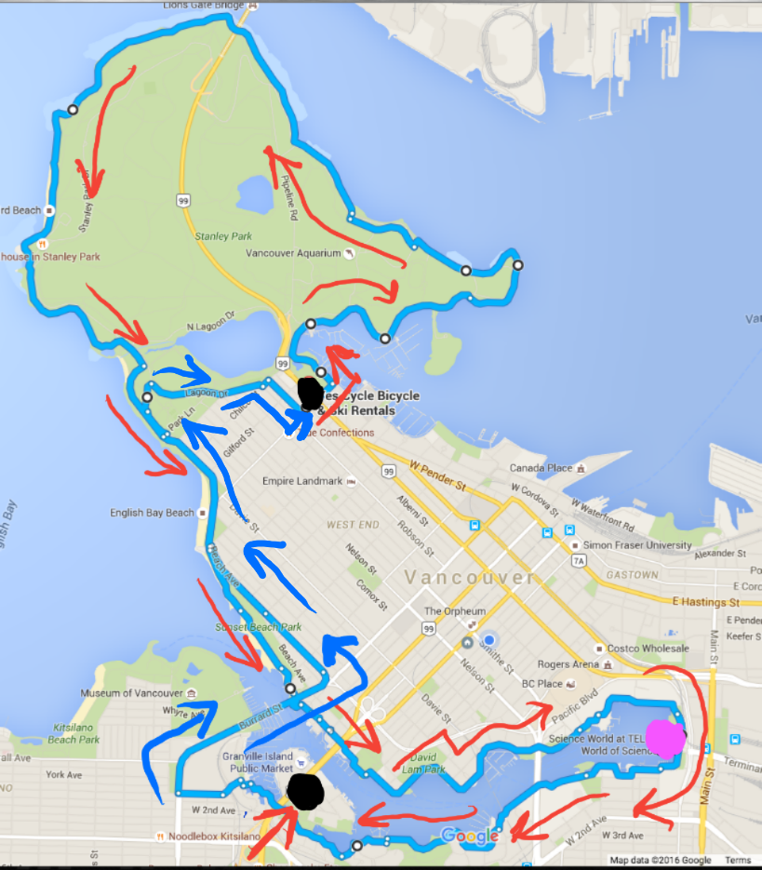

Option 2: For this group only the Stanley Park will be covered but more time is spent in the park.

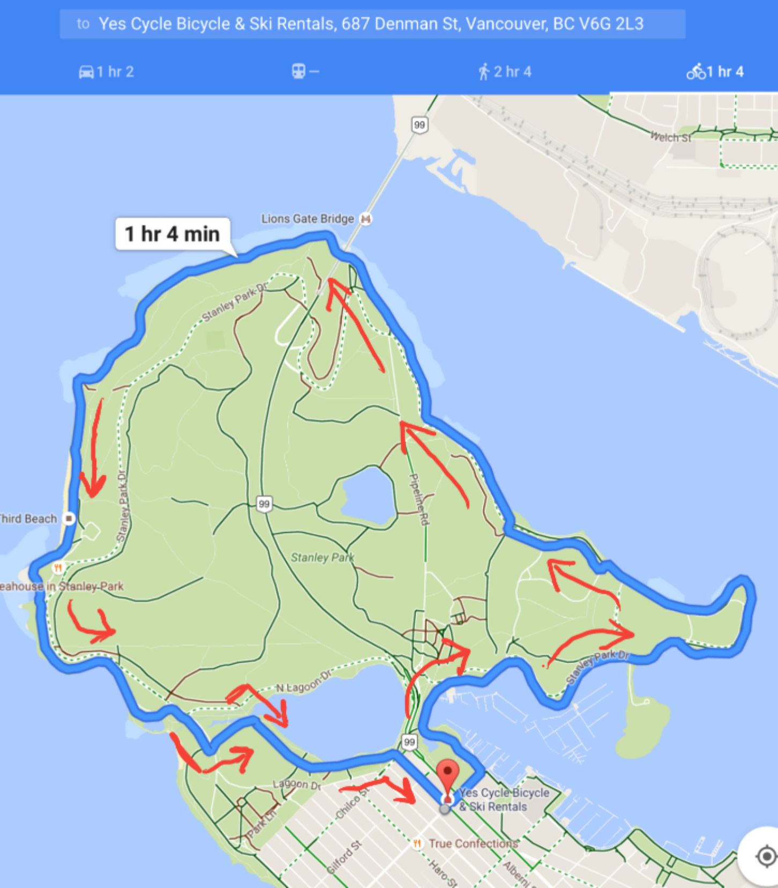

## Wednesday Farewell

For those who are athletic and would like a physical challenge at the end of the conference we will arrange a hike to Grouse mountain which has a beautiful view of Vancouver. This is a one to two hour hike, depending on the level of your fitness. We leave at 4:30 PM from the conference site using public transit. If interested, register your name at the help desk and you will be provided with more detail during the conference.

# Sunday Symposium

The topic of this year's symposium will be Cardiology and Space Flight, where six exciting talks by renowned experts in the field will look at the heart and cardiovascular system in the space environment. The tentative program will be as follows:

13h00-13h45: Registration

13h45-14h00: Opening remarks

14h00-14h45: Dr. Robert Thirsk, Canadian Astronaut, Chancellor, University of Calgary, Calgary, Alberta, Canada, ​Surviving and Thriving in Space - The Medical Consequences of Spaceflight

14h45-15h15: Dr. Peter Norsk, Chief Scientist at USRA, Element Scientist NASA-JSC. Cardiovascular adaptation to spaceflight: Surprises and paradoxes

15h15-15h45: Dr. Pierre-Francois Migeotte. Three-Dimensional Ballistocardiography: from space research to clinical applications.

15h45-16h30: Coffee break

16h30-17h00: Dr. J. Kevin Shoemaker, University of Western Ontario, London, Ontario, Canada Simulated Microgravity and the Autonomic Nervous System

17h00-17h30: Dr. Victor Convertino,  The use of advanced machine learning to assess cardiovascular compensation in conditions of central hypovolemia: lessons learned from space and trauma.

17h30-18h00: Dr. Erik Seedhouse, Embry-Riddle Aeronautical University, Daytona, FL, USA Application of bioinstrumentation in the development of a pressure suit for suborbital flight

18h00-18h30: Closing remarks and discussion

19h00-21h00: Reception at Marriott Pinnacle Hotel (Conference Hotel)..

## For Authors and Speakers

### Oral Presentations

The time allocated for each oral presentation is 10 minutes, followed by 5 minutes for discussion (except for Physionet Challenge sessions). Speakers are expected to adhere strictly to this schedule, which will be enforced by session chairpersons in order to finish sessions on time and to permit participants to move successfully from one parallel session to another.

* All conference rooms will be equipped with a computer projection system (LCD projector and PC with Windows 7, Powerpoint 2013, Windows Media Player and Adobe Acrobat Reader).
* Due to Powerpoint version issues, PDF format is probably the most reliable one.
* Some MacBooks will be also at disposal.

Speakers are required to allow adequate time prior to their sessions to load and check their presentations. In addition, speakers are required to meet with their session chairpersons in the scheduled conference room at least 10 minutes before the beginning of the session. It is a good idea to ensure that the chairperson knows how to correctly pronounce your name.

### Poster Presentations

Poster sessions will take place, on Tuesday, 13th September from 12:30 , and on Wednesday, 14th September, from 12:30. Authors are required to be present at their posters during their assigned session in order to discuss their work with other conference attendees.

* Check in: Authors presenting posters must check in with the session chair in the exhibition Centre during the 30 minutes prior to the poster sessions in which their presentations are scheduled
* Posters may be hung between 8:30 and 12:00 for the Tuesday and Wednesday sessions
* The maximum poster size is 172 cm (68") wide and 112 cm (44") tall.
* Posters are grouped by subjects area, and each poster should be hung on the stand assigned to it (marked with a card corresponding to the page number of the abstract in the program book)

Posters must be removed immediately after the end of the sessions to allow the timely cleaning of the Exhibition room

# Rosanna Degani Young Investigator Award

Computing in Cardiology runs an annual competition to encourage young investigators and to provide a living memorial to Rosanna Degani. The competition for the 2016 Rosanna Degani Yound Investigator Award was open to persons under 36 years of age. Finalists in the competition will present their work in session M1, at 8:15 on Moday, 12th September. The name of the winner will be announced during the closing plenary session on Wednesday.

# PhysioNet/Computing in Cardiology Challenge 2015

Since 2000, Computing in Cardiology has annually issued a Physionet Challenge in cooperation with Physionet, part of the NIH sponsored Research Resource for Complex Physiologic Signals. The aim of this year’s challenge is “the development of algorithms to classify heart sound recordings collected from a variety of clinical or nonclinical (such as in-home visits) environments”. The challenge sessions are on Tuesday, afternoon and Wednesday morning

# Manuscripts

Computing in Cardiology will publish the conference proceedings containing the complete manuscripts of all presentations. The complete proceedings will be freely available via the CinC Web site (**http://www.cinc.org**). Also they will be published by IEEE at their IEEEXplore digital library. For any questions about manuscripts, consult the CinC web site **http://www.cinc.org** or contact via email Alan Murray, the Editor of the proceedings: Alan.Murray@ncl.ac.uk